**ANGULAR**

## **What Is Angular?**

Angular is an open-source, [JavaScript](https://www.simplilearn.com/tutorials/javascript-tutorial/introduction-to-javascript) framework written in [TypeScript](https://www.simplilearn.com/tutorials/typescript-tutorial/typescript-interview-questions). Google maintains it, and its primary purpose is to develop single-page applications. As a framework, Angular has clear advantages while also providing a standard structure for developers to work with. It enables users to create large applications in a maintainable manner.

## **Why Do You Need a Framework?**

Frameworks in general boost web development efficiency and performance by providing a consistent structure so that developers don’t have to keep rebuilding code from scratch. Frameworks are time savers that offer developers a host of extra features that can be added to software without requiring extra effort.

## **Why Angular?**

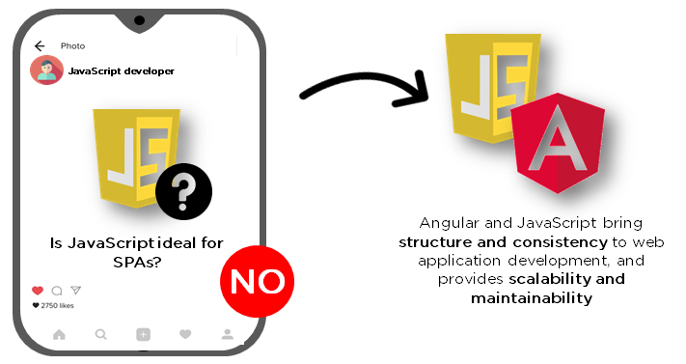

[JavaScript](https://www.simplilearn.com/reasons-to-learn-javascript-article) is the most commonly used client-side scripting language. It is written into [HTML](https://www.simplilearn.com/tutorials/html-tutorial/what-is-html) documents to enable interactions with web pages in many unique ways. As a relatively easy-to-learn language with pervasive support, it is well-suited to develop modern applications.

But is JavaScript ideal for developing single-page applications that require modularity, testability, and developer productivity? Perhaps not.

These days, we have a variety of frameworks and libraries designed to provide alternative solutions. With respect to front-end web development, Angular addresses many, if not all, of the issues developers face when using JavaScript on its own.

## **What are the Different Angular Versions:**

“Angular” is the catch-all term for the various framework versions out there. Angular was developed in 2009, and as a result, there have been many iterations.

First, there was the original Angular, called Angular 1 and eventually known as AngularJS. Then came Angulars 2, 3, 4, 5, until finally, the current version, Angular 13, released on 04/11/2021. Each subsequent Angular version improves on its predecessor, fixing bugs, addressing issues, and accommodating increasing complexity of current platforms.

If you want to design apps better suited for mobile devices, and/or more complex apps, you had best to upgrade to its current version.

## **Features of Angular**

### **1. Document Object Model**

DOM (Document Object Model) treats an [XML](https://www.simplilearn.com/tutorials/programming-tutorial/what-is-xml) or HTML document as a tree structure in which each node represents a part of the document.

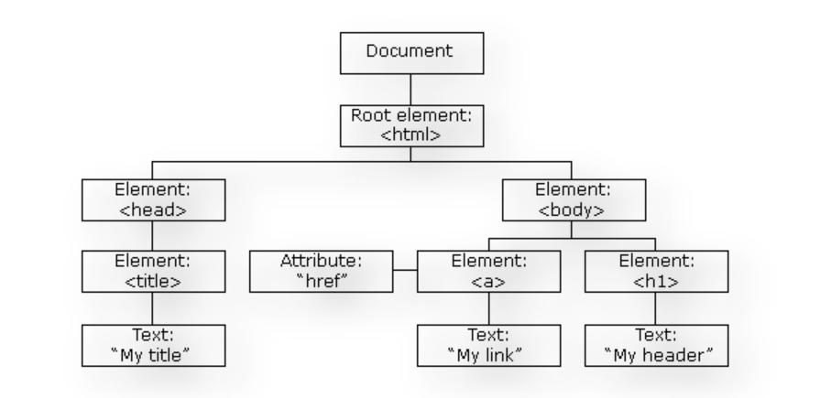

Angular uses regular DOM. Consider that ten updates are made on the same HTML page. Instead of updating the ones that were already updated, Angular will update the entire tree structure of HTML tags.

### **2. TypeScript**

TypeScript defines a set of types to JavaScript, which helps users write JavaScript code that is easier to understand. All of the TypeScript code compiles with JavaScript and can run smoothly on any platform. TypeScript is not compulsory for developing an Angular application. However, it is highly recommended as it offers better syntactic structure—while making the codebase easier to understand and maintain.

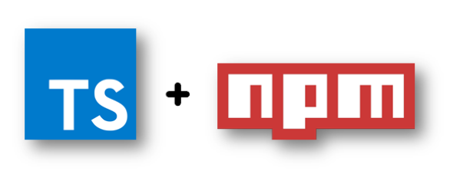

You can install TypeScript as an NPM package with the following command:

npm install -g typescript

### **4. Testing**



Angular uses the [Jasmine testing framework](https://en.wikipedia.org/wiki/Jasmine_(JavaScript_testing_framework)). The Jasmine framework provides multiple functionalities to write different kinds of test cases. Karma is the task-runner for the tests that uses a configuration file to set the start-up, reporters, and testing framework.